Waste Management Practices
A Comparative Study: India, Israel, Germany, UK & Russia

Introduction
Waste management is one of the most pressing environmental challenges of the modern era. As populations grow and consumption patterns intensify, countries face mounting pressure to manage municipal, industrial, and hazardous waste responsibly. This document examines how India, Israel, Germany, the United Kingdom, and Russia approach waste management, highlighting their policies, infrastructure, challenges, and successes, followed by a comparative analysis.

Country Profiles

India
India generates enormous volumes of municipal solid waste due to its large and growing population and rapid urbanization. The Swachh Bharat Mission (Clean India Mission), launched in 2014, has been central to improving sanitation and waste collection nationwide. The Solid Waste Management Rules, 2016 mandate source segregation into wet, dry, and hazardous waste categories, though implementation remains inconsistent across cities.
Much of India's waste still ends up in open dumpsites and unscientific landfills, contributing to air and groundwater pollution. However, cities like Indore have demonstrated that structured door-to-door collection and segregation can achieve near-total waste processing. The informal recycling sector, comprising millions of waste-pickers, plays a significant unofficial role in recovering recyclable materials.
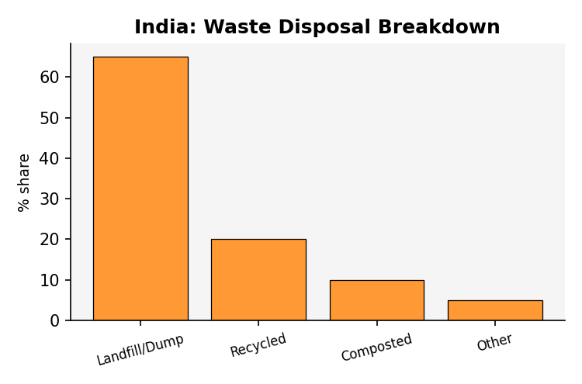

Israel
Israel faces land scarcity, which makes landfilling an increasingly unsustainable long-term solution. The country has historically relied heavily on landfills, with recycling rates trailing behind other developed nations. The Clean Israel Law and the Deposit Law on beverage containers aim to reduce litter and encourage recycling of packaging materials.
In recent years, Israel has invested in waste-to-energy initiatives and advanced sorting facilities, such as the Hiriya recycling park near Tel Aviv, which transformed a former landfill into a recycling and composting hub. Extended Producer Responsibility (EPR) regulations for packaging are gradually shifting the burden of recycling onto manufacturers.
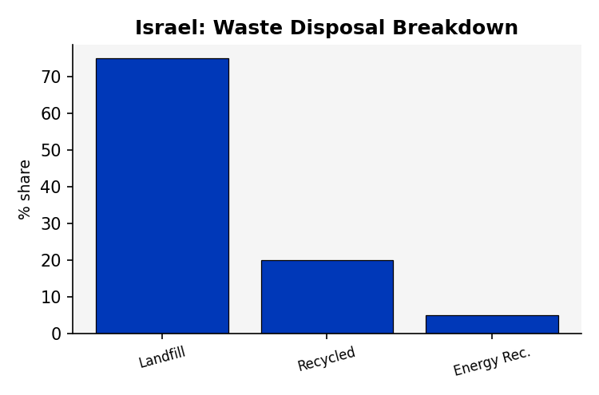

Germany
Germany is widely regarded as a global leader in waste management, achieving one of the highest recycling rates in the world. The Kreislaufwirtschaftsgesetz (Circular Economy Act) enforces a strict waste hierarchy: avoidance, reuse, recycling, energy recovery, and disposal, in that order of priority.
The country's household waste separation system uses color-coded bins for paper, biodegradable waste, packaging, and residual waste. The Green Dot (Der Grüne Punkt) system requires producers to fund the collection and recycling of packaging waste. Germany also operates state-of-the-art waste-to-energy incineration plants that convert non-recyclable waste into electricity and heat.
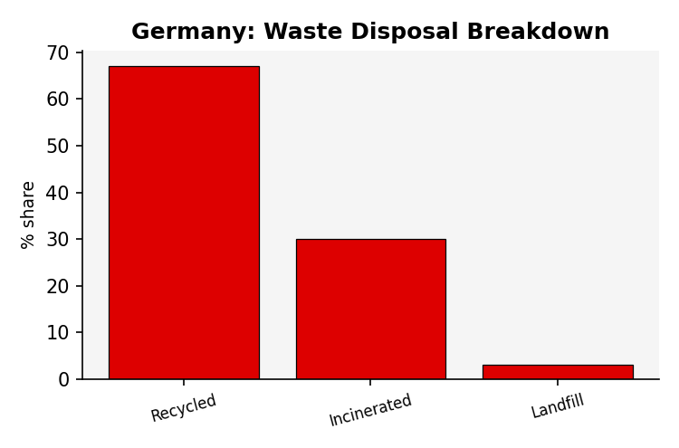

United Kingdom
The UK manages waste through a combination of local council collection schemes, recycling targets, and landfill taxes designed to discourage disposal in landfills. The Environment Act 2021 introduced stronger Extended Producer Responsibility rules and consistent recycling collection standards across England.
Recycling rates vary significantly between local authorities, with Wales generally outperforming England, Scotland, and Northern Ireland. The UK has expanded energy-from-waste incineration to reduce landfill dependency, though this has drawn criticism from environmental groups concerned about emissions and reduced incentives for recycling.
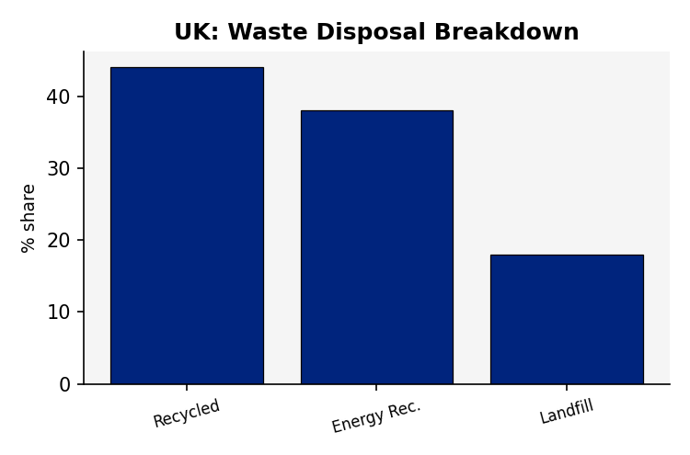

Russia
Russia has historically relied almost entirely on landfilling, with recycling rates among the lowest of major economies. Vast, sparsely populated territory made landfill disposal the default option for decades, but landfills near major cities like Moscow have become overwhelmed, sparking public protests over health and environmental concerns.
In 2019, Russia launched a National Waste Management Reform, introducing regional operators responsible for waste collection and establishing targets for recycling infrastructure development. Progress remains slow, and separate collection systems are only beginning to appear in major cities, but the government has signaled a commitment to reducing landfill dependency over the coming decade.
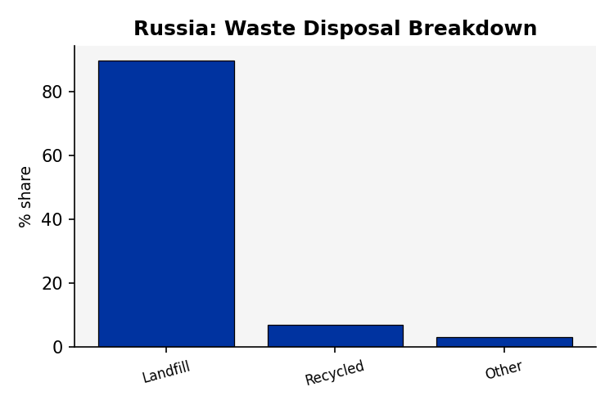

Comparative Analysis
The table below summarizes key waste management indicators across the five countries, illustrating the wide variation in recycling performance, policy maturity, and disposal methods.
Aspect | India | Israel | Germany | UK | Russia
Approx. Recycling Rate | ~30% | ~20% | ~67% | ~44% | ~7%
Waste per Capita/Day | ~0.5 kg | ~1.7 kg | ~1.4 kg | ~1.4 kg | ~0.9 kg
Primary Disposal Method | Landfilling & open dumping | Landfilling (transitioning) | Incineration & recycling | Landfill & Energy Recovery | Landfilling (dominant)
Segregation at Source | Improving, inconsistent | Limited, expanding | Mandatory, strict | Council-mandated, varies | Largely absent, growing
Key Policy Framework | Swachh Bharat Mission, SWM Rules 2016 | Clean Israel Law, Deposit Law | Kreislaufwirtschaftsgesetz (Circular Economy Act) | Environment Act 2021, EPR | National Waste Reform 2019
Producer Responsibility (EPR) | Yes, expanding | Yes, for packaging | Yes, comprehensive (Green Dot) | Yes, reforms underway | Yes, newly introduced
Waste-to-Energy Use | Growing, limited | Minimal | Extensive | Significant | Minimal, emerging

Visual Comparison
The chart below compares the approximate municipal waste recycling rate across the five countries. Germany leads by a wide margin due to its mature circular economy infrastructure, while Russia lags due to continued heavy reliance on landfilling.
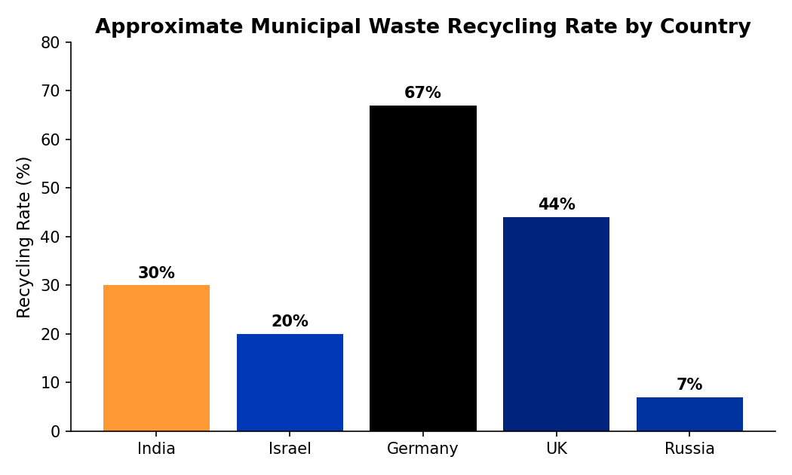
The next chart shows approximate daily per-capita municipal waste generation. Higher-income countries such as Israel, Germany, and the UK tend to generate more waste per person, whereas India's per-capita generation remains comparatively lower, though its total volume is very high due to population size.
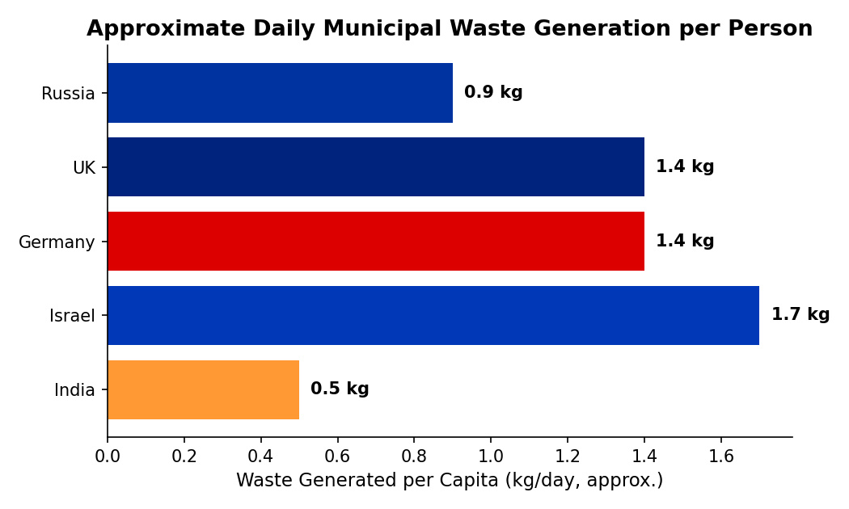

Key Takeaways
- Germany demonstrates that strict source-segregation laws combined with producer responsibility schemes can achieve very high recycling rates.
- India and Russia both face the challenge of scaling formal waste infrastructure to match large populations and territories, though their situations differ — India relies on emerging municipal programs and an informal recycling sector, while Russia is beginning nationwide reform after decades of landfill dependence.
- Israel's land scarcity is pushing policy toward greater recycling and waste-to-energy investment, despite a historically landfill-heavy approach.
- The UK shows how landfill taxes and evolving producer-responsibility regulation can shift waste management incentives, though performance still varies by region.
- Across all five countries, extended producer responsibility (EPR) and the transition toward a circular economy are emerging as common policy directions.

Conclusion
While each country's approach to waste management is shaped by its unique geography, population density, economic development, and policy history, a common global trend is emerging: growing emphasis on source segregation, extended producer responsibility, and circular economy principles. Germany currently stands as a benchmark for recycling efficiency, while India and Russia illustrate the challenges of scaling reform across vast and populous nations. Continued investment in infrastructure, public awareness, and enforceable policy will be essential for all five countries to manage waste sustainably in the decades ahead.

